Imbalanced Datasets
Teaching Notes
A from-scratch guide to classification when one class is rare. Explains why accuracy fails, what class weighting, oversampling, undersampling, and SMOTE actually do, and a numeric proof of what they really change, grounded in the fraud-detection case study's own verified results.

Contents

1. The Accuracy Trap
Every classification case study so far has assumed both classes are reasonably well represented. Many real problems aren't: fraud, disease, equipment failure, churn, the outcome you actually care about is often rare, sometimes under 5% of the data. When one class dominates this heavily, a model's overall accuracy stops being a trustworthy signal of whether it's any good.
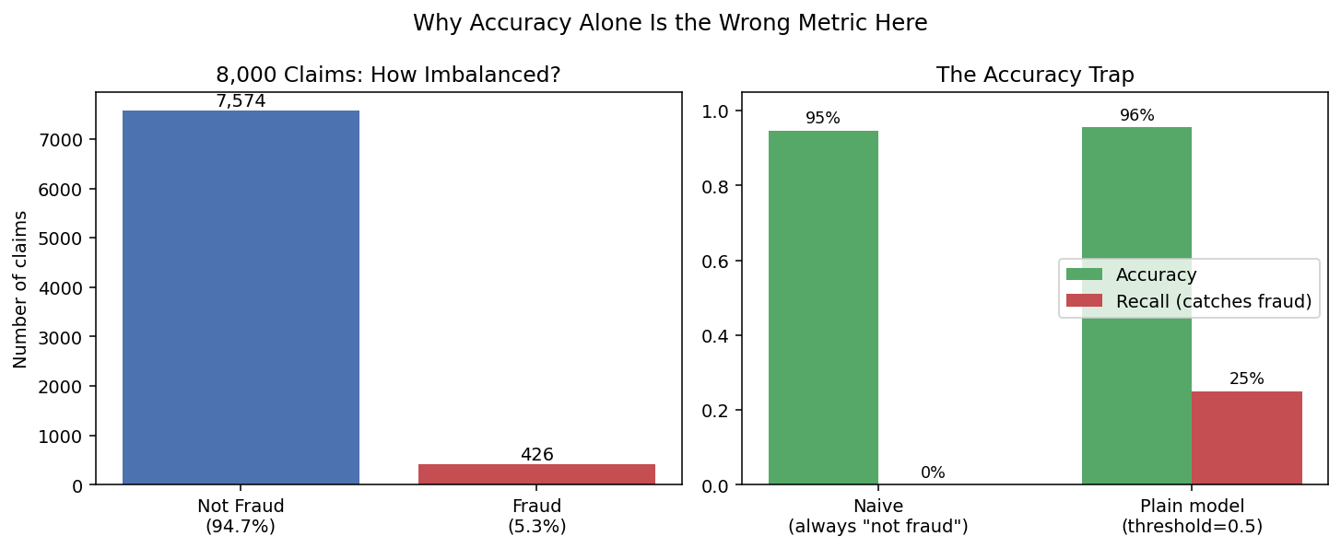
Figure 1. Left: 8,000 insurance claims, only 5.3% (426) are fraudulent. Right: a model that never flags anything as fraud still scores 94.7% accuracy, and a plain classifier trained on this data reaches 95.5% accuracy while catching only 25% of actual fraud.
The problem is arithmetic, not modeling. When 94.7% of claims are legitimate, simply guessing “not fraud” every single time is already right 94.7% of the time, without learning anything at all. Any accuracy number on imbalanced data has to be judged against this do-nothing baseline, not against 100%. On data this skewed, accuracy should be dropped as the headline metric entirely.

2. Metrics That Actually Work on Imbalanced Data
Metric | What it answers | Use it when…
Recall | Of all the real positive cases, how many did we catch? | Missing a positive case (fraud, disease) is the costly mistake
Precision | Of everything we flagged, how many were actually positive? | Investigating a false alarm is the costly mistake
F1 | A single balance of recall and precision | You need one number and care about both roughly equally
ROC-AUC | How well the model ranks positives above negatives, at every possible threshold | Comparing models' underlying quality, independent of any specific cutoff
PR-AUC | Like ROC-AUC, but focused on precision at each recall level | The positive class is rare (more honest than ROC-AUC in that case, Section 6)

None of these five requires accuracy to be abandoned entirely, it's still worth reporting, just never as the only number, and never as proof a model works.

3. The Imbalanced-Data Toolbox
Four standard techniques exist to push a model toward paying more attention to the rare class. All four were tested side by side in the case study, on the exact same train/test split, so the comparison below is apples-to-apples:

Class Weighting
Penalize the model more heavily for misclassifying the rare class during training, no data is duplicated or removed, only the loss function's arithmetic changes.
class_weight="balanced" (scikit-learn automatically weights each class inversely to its frequency)

Random Oversampling
Duplicate existing minority-class (fraud) rows until the training set is balanced.

Random Undersampling
The reverse: discard majority-class (non-fraud) rows until the training set is balanced. Simple, but throws real data away, a concern when the majority class is only modestly sized to begin with.

SMOTE (Synthetic Minority Oversampling Technique)
Instead of duplicating existing minority rows exactly, generate new, synthetic minority examples by interpolating between real minority points and their nearest minority neighbors, adding variety rather than exact repeats.

4. Do They Actually Work? The Verified Comparison
Approach | Recall | Precision | F1 | ROC-AUC
Plain (no adjustment) | 0.250 | 0.727 | 0.372 | 0.885
Class Weighting | 0.812 | 0.204 | 0.326 | 0.892
Random Oversampling | 0.820 | 0.206 | 0.329 | 0.892
Random Undersampling | 0.797 | 0.208 | 0.330 | 0.886
SMOTE | 0.805 | 0.211 | 0.335 | 0.893

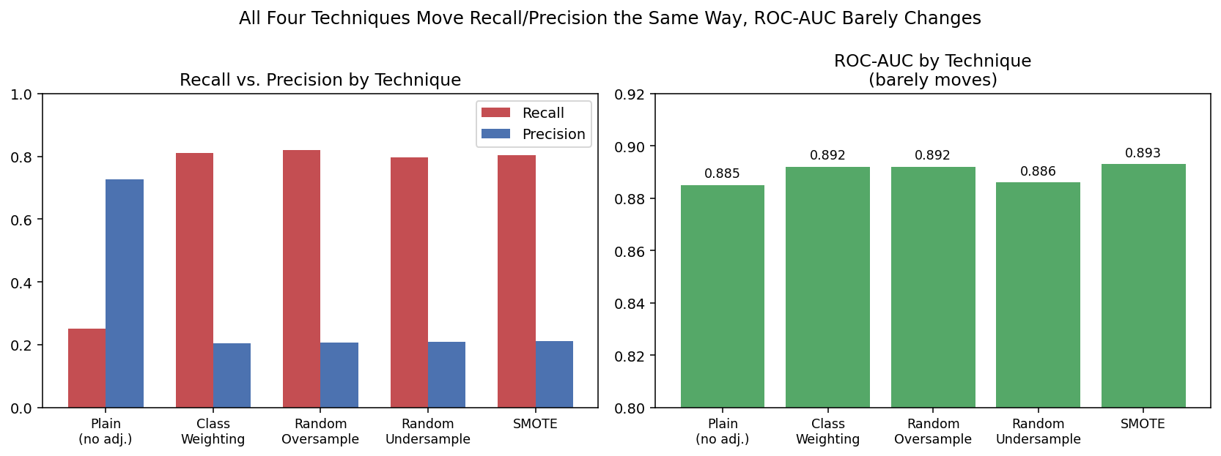
Figure 2. Left: all four techniques move recall from ~25% to ~80%, at a steep, near-identical cost to precision. Right: ROC-AUC barely changes across any of them, all sit within 0.885–0.893, essentially the plain model's own score.
All four techniques produced a large, similar recall gain. None showed a meaningfully better ROC-AUC than the plain model. That's the detail worth chasing: if these techniques were teaching the model something new, ranking quality should have improved. It didn't, meaningfully.

5. What's Actually Happening: A Numeric Proof
A linear model like logistic regression outputs a probability, then applies a cutoff (0.5 by default) to turn that probability into a yes/no prediction. Class weighting and resampling both change how the model is trained, but for a linear model, changing training mostly just shifts where its probabilities land relative to that fixed 0.5 cutoff, it doesn't necessarily change the underlying probabilities' ranking. The case study tested this directly: take the plain model (Section 4's first row, never resampled or reweighted) and simply lower its cutoff until it matches the class-weighted model's recall.
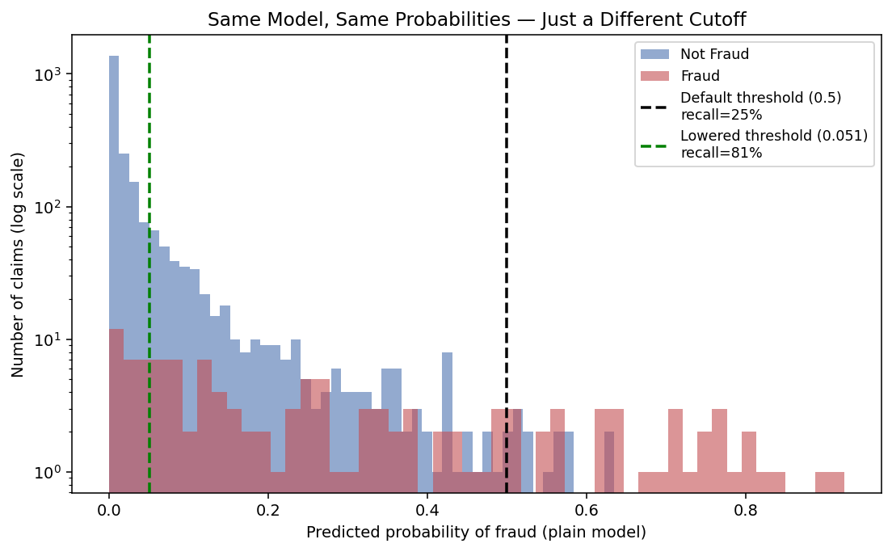
Figure 3. The exact same plain model's predicted probabilities for every test claim. Moving the cutoff from 0.5 down to 0.051 changes nothing about the model itself, only which claims fall on the “flag as fraud” side of the line.
 | Recall | Precision
Plain model, threshold lowered to 0.051 | 0.812 | 0.197
Class-weighted model (threshold 0.5) | 0.812 | 0.204

At matched recall, precision is nearly identical (0.197 vs. 0.204), a difference easily explained by ordinary variation, not a real gap. For this linear model, class weighting achieved almost exactly what manually lowering the threshold achieved on its own.
This does not mean class weighting, oversampling, and SMOTE are pointless. It means their main value here is convenience, they save the work of manually threshold-searching, and they remain the standard, well-understood approach worth reaching for by default. But it's worth knowing what they are and are not doing: for a linear model, they are mostly a principled way to move the decision boundary, not a way to teach the model new information it couldn't already see.
Important caveat: this equivalence is a property of linear models specifically. For tree-based ensembles (Random Forest, Gradient Boosting), resampling changes which splits the model considers during training itself, a genuinely different mechanism that plain threshold-tuning on an unresampled model cannot reproduce. Re-test this comparison before assuming it transfers to a different model family.

6. Why Precision-Recall Curves, Not Just ROC, on Imbalanced Data
An ROC curve plots true positive rate against false positive rate. On heavily imbalanced data, the false positive rate can look deceptively small simply because the negative class is so large, a model can rack up hundreds of false alarms and still show a tiny false-positive rate, because it's dividing by a huge negative-class count. A precision-recall curve avoids this: it plots precision directly against recall, showing exactly what precision costs at every recall level, a much more honest picture when positives are rare.
Random-guessing PR baseline = the positive class rate itself (5.3% here), not 0.5 as it would be for a balanced ROC curve
In the case study, the plain model and the SMOTE model traced nearly the same precision-recall curve (PR-AUC of 0.482 and 0.457 respectively), both far above the 5.3% random-guessing baseline, further confirming that SMOTE changed the operating point far more than it changed the model's underlying discriminative ability.

7. Practical Guidance
- Never report accuracy alone on imbalanced data, pair it with recall, precision, and ROC-AUC or PR-AUC at minimum.
- Start simple: try class_weight="balanced" first (a one-line change) before reaching for resampling libraries, for a linear model it will often get you most of the way there.
- Prefer SMOTE over plain random oversampling when you do resample, synthetic variety tends to generalize slightly better than exact duplicates, though the difference is often modest.
- Use undersampling cautiously, it discards real data and can hurt more than help when the majority class isn't enormous to begin with.
- Treat the final decision threshold as a business decision: it should reflect the real relative cost of a missed positive versus a false alarm, not default to 0.5 by habit.
- Re-test the resampling-vs-threshold-shifting comparison from Section 5 whenever moving to a non-linear model family (trees, ensembles), the equivalence found here does not automatically carry over.

8. Summary Cheat Sheet
- On imbalanced data, high accuracy can hide a model that catches none of the rare, important class, always check recall and precision alongside it.
- Class weighting, random oversampling, random undersampling, and SMOTE all push a model toward better recall on the rare class, at a real precision cost.
- For a linear model, these techniques mainly shift the effective decision threshold, verified directly by reproducing the same recall/precision tradeoff just by lowering a plain model's cutoff (Section 5).
- ROC-AUC barely changing across techniques is the tell: if ranking quality isn't improving, the technique is repositioning the decision boundary, not adding new information.
- Precision-recall curves, not ROC curves, are the more honest visual once the positive class is rare (Section 6).
- The right decision threshold is a business call about relative costs, not a modeling default, and this whole comparison should be re-verified before assuming it holds for non-linear model families.

